|  |  |  |  |  |  |  |
| --- | --- | --- | --- | --- | --- | --- |
| https://upload.wikimedia.org/wikipedia/en/3/33/BSHS_Logo.jpg | Bunbury Senior High School | | | | | |
| **CHEMISTRY UNIT 3 & 4** | | | | | | |
| **Test #5:** | | | | | | |
| **Organic Chemistry 2** | | | | | | |
|  | | | | | | |
| **NAME:** | | |  | | | |
|  | | |  | | | |
| **Time allowed for this paper** | | | | | | |
| Reading time: | | 5 minutes | | | | |
| Working time: | | 50 minutes | | | | |
|  | | | | | | |
| **Structure of this paper:** | | | | | | |
| Section | | | Number of questions | Marks available | | Marks achieved |
| Section One: Multiple Choice | | | 10 | 10 | |  |
| Section Two: Short Answer | | | 10 | 58 | |  |
|  | | |  | | **Total** | ______ / 68 |

**Section One: Multiple Choice**

1. Which of the following is an α-amino acid?

H2N

CH2

CH2

COOH

CH

COOH

CH2

NH2

1. (b)

COOH

NH2

CH

CH3

CH3

CH2

CH

CH

OH

CH2

CH2

CH

SH

H2N

COOH

(c) (d)

1. Consider the following molecule.

HO

O

O

C – C – C – CH3

CH3

H

Which of the following substances could be oxidised to form the molecule above?

1. CH3CHOHCH(CH3)CH3
2. CH3CH(CH3)CHOHCH2OH
3. CH2OHCH2COH(CH3)CH3
4. CH3CHOHCH(CH3)CH2OH
5. A student’s study notes on protein structure included these four unlabelled sketches:

|  |  |
| --- | --- |
| H  H  H  N  C  C  O  O  H  R |  |
| **I** | **II** |
| Ala  His  Met  Ala  Pro |  |
| **III** | **IV** |

Which sketches best represent the primary, secondary and tertiary structure of proteins?

|  |  |  |  |
| --- | --- | --- | --- |
|  | **Primary structure** | **Secondary structure** | **Tertiary structure** |
| (a) | I | II | IV |
| (b) | I | IV | II |
| (c) | III | IV | II |
| (d) | III | II | IV |

1. Which of the following properties of a protein is least likely to be affected by changes in pH?
2. Net charge
3. Secondary structure
4. Tertiary structure
5. Primary structure
6. Which of the following best explains why heptane has a higher boiling point than 2,3-dimethylpentane?
7. Heptane contains more hydrogen bonds than 2,3-dimethylpentane and so has stronger intermolecular forces
8. Heptane is more polar than 2,3-dimethyl pentane and so has stronger dipole-dipole forces
9. Heptane has less branched groups than 2,3-dimethylpentane and so has stronger dispersion forces
10. Heptane has a higher molecular weight than 2,3-dimethylpentane and so has stronger dispersion forces
11. Which of the following equations correctly represents the substitution reaction that would occur between butane and chlorine water?
12. CH3CH=CHCH3 + Cℓ2 → CH3CHCℓCHCℓCH3
13. CH3CH2CH2CH3 + Cℓ2 → CH3CH2CHCℓCH3 + HCℓ
14. CH3CH2CH2CH3 + Cℓ2 → CH3CH2CHCℓ2 + CH4
15. CH3CH2CH2CH3 + Cℓ2 → CH3CH2CCℓ2CH3  + H2
16. What is the IUPAC name of the following compound?



1. 3-methylpentan-3-al
2. 2-ethylbutanal
3. 2,2-diethylethanal
4. 2-methylbutanal
5. Which of the following compounds will react (in the presence of concentrated sulfuric acid) with its own oxidation product to give a sweet-smelling liquid?
6. Propanal
7. propan-1-ol
8. propan-2-ol
9. propanone
10. For which of the following organic molecules does the structural diagram match the correct IUPAC name given?

|  |  |  |
| --- | --- | --- |
| (i) | (ii) | (iii) |
|  |  |  |
| 2-methylpentan-4-one | 1,2,3-trichloropropene | aminoethanal |

1. (i) only
2. (i) and (ii) only
3. (ii) only
4. (ii) and (iii) only
5. Which one of the following lists places the compounds in their correct class?

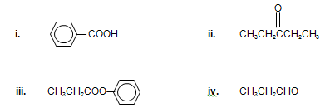

1. **ii iii iv**
2. Ester Aldehyde Ketone Carboxylic acid
3. Carboxylic acid Ketone Ester Aldehyde
4. Carboxylic acid Ester Ketone Aldehyde
5. Aldehyde Ketone Carboxylic acid Ester

**Section Two: Short Answer**

Write your answers in the spaces provided.

1. **(3 marks)**
   1. Define the term ‘functional group’. (1 mark)

* 1. Circle and name the three functional groups in the molecule below. (1 mark)

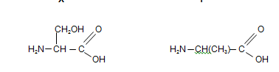

* 1. What type of organic molecule is shown in the above diagram? (1 mark)

1. **(7 marks)**

Use structural formulae to show the organic product(s) of the following reactions.

Show all bonds around functional groups clearly. e.g. write 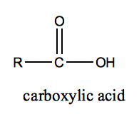 instead of -COOH.

If no reaction occurs, state this clearly.

|  |  |
| --- | --- |
| **Reactants** | **Structure of organic product(s)** |
| CH3CH=CHCH3 + H2O |  |
| CH3CHCH2CH2CH3 + KMnO4  |  OH |  |
| Ethanol + butanoic acid (and a suitable catalyst) |  |
| CH2=CHCHO + Cℓ2(g) |  |
| CH3CH(CH3)CH2CH2CH3 + Br2(g) |  |
| CH3CHNH2COOH + H2NCCOOH |  |

1. **(7 marks)**

Some alkenes are capable of *cis-trans* isomerism.

* 1. Use isomers of C4H8 to support your answers to define cis-trans isomerism. (5 marks)

* 1. One alkene with the formula C4H8 cannot form *cis-trans* isomers. Draw this form of the molecule and explain why it does not show *cis-trans* isomerism. (2 marks)

1. **(7 marks)**

Compound E may be synthesised using the following process.

Draw the structural formulae of compounds A, B, C, D and E in the boxes provided.

Write the systematic names of compounds C and E in the spaces provided.

H2SO4

H2O catalyst

HCl

Cr2O72- /H+

NaOH

**Compound C**

Structural formula:

Name:

**Compound A**

Structural formula:

**Compound B**

Structural formula:

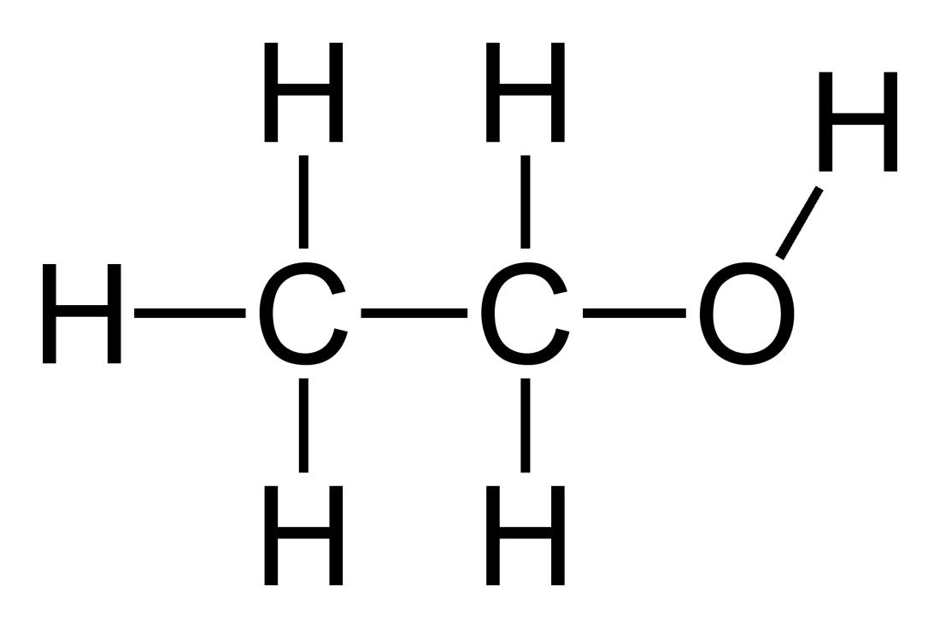

1-chloropropane

**Compound D**

Structural formula:

**Compound E**

Structural formula:

Name:

1. **(6 marks)**

Phenylalanine (chemical structure shown below) is an essential α-amino acid.

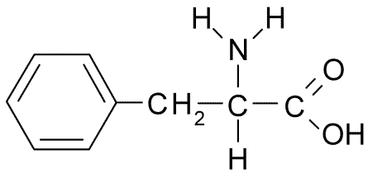

* 1. In neutral solutions at pH 7, phenylalanine exists as a zwitterion. Draw the structure of the zwitterion form of phenylalanine. (1 mark)

* 1. When crystallised from a neutral solution, phenylalanine exists as a crystalline solid. The solid has a melting point of 283°C, whereas phenylethanoic acid, a molecule of similar size, has a melting point of 76°C. With reference to the structure in (a), explain the physical properties of phenylalanine. (3 marks)

* 1. The structure of amino acids is dependent on pH. Draw the structure of the α-amino acid **lysine** under the following pH conditions. *(Refer to your data book for the structure of lysine)* (2 marks)

|  |  |
| --- | --- |
| **pH** | **Structure of lysine** |
| 2 |  |
| 12 |  |

1. **(7 marks)**

Amino acids can be classified according to the nature of their side chains. These may be polar, non-polar, acidic or basic.

* 1. Referring to the data book, name one amino acid with a non-polar side chain (1 mark)

* 1. Referring to the data book, name one amino acid with an acidic side chain. (1 mark)

* 1. The table below provides examples of different categories of side chains at pH 7.



The tertiary structure of proteins is a result of the bonding between the side chains of amino acid residues. Use the information in the table to

1. Identify the amino acid that is involved in the formation of disulphide bonds (1 mark)

1. Give an example of two amino acids side chains that may form hydrogen bonds between each other (1 mark)

1. Give an example of amino acid side chains that may form ionic bonds between each other. (1 mark)

1. Identify the type of bonding that exists between the side chains of two alanine residues. (1 mark)

1. **(3 marks)**

The following screenshot shows the structure of 5EPZ, a human angiogenin protein.

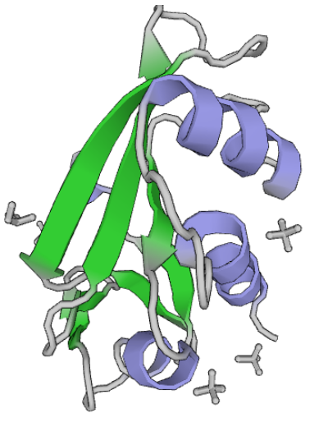

Y:

X:

* 1. Label the above diagram by naming the outlined features (X and Y). (1 mark)
  2. Explain what leads to the formation of the structures represented with the letter X. (2 marks)

1. **(6 marks)**

Compounds similar to that shown below are responsible for the odour of some cheeses.



* 1. State the systematic (IUPAC) name of the compound shown above. (1 mark)

* 1. This compound can be produced by the oxidation of an alcohol with acidified potassium permanganate solution.

Write the half equation for the oxidation of this alcohol to the compound shown above. (2 marks)

Write the half equation for the reduction of the acidified permanganate ion (MnO4-) and hence write the overall redox equation for the reaction. (3 marks)

1. **(6 marks)**

Myrcene is a naturally occurring compound found in the leaves of bay trees. It is known to be a polyunsaturated hydrocarbon. It can react with hydrogen to produce a saturated hydrocarbon.

In a laboratory investigation, a 1.00 g sample of myrcene fully reacted with exactly 510 mL of hydrogen gas measured as 20.0 °C and 105.0 kPa. In this reaction, myrcene was converted to a saturated alkane with a molecular formula C10H22. Both reactants were fully consumed in the reaction (i.e. no reactant was in excess).

* 1. What type of reaction has occurred between the myrcene and hydrogen? (1 mark)

* 1. Calculate the number of moles of hydrogen gas reacting. (1 mark)

* 1. Calculate the mass of C10H22 produced in the reaction. (2 marks)

* 1. Determine the number of double bonds in each molecule of myrcene. (2 marks)

1. **(14 marks)**

Substance F is a colourless liquid. The substance was known to contain carbon and hydrogen. It is difficult to test for the presence of oxygen in organic compounds, so oxygen may or may not be present in substance F.

* A 0.45 g sample of the compound was combusted in an excess of oxygen, producing 0.493 g of water and 0.797 L of carbon dioxide gas at 22.4 °C and 101.3 kPa.
* The density of the colourless liquid at 25 °C was measured to be 0.811 g/mL. A 5.00 mL aliquot of this liquid was collected using a volumetric pipette and then vaporised at a temperature of 114 °C. The resulting vapour was transferred to a 1.00 L container and the pressure of the vapour was measured to be 159 kPa.

From the information provided, calculate the molecular formula and empirical formula of substance F.

**SPARE PAGE**